All Native Outreach Marketing and packaged media is due three weeks prior to the scheduled date. Please send all content at one time. Remember that the meeting planner is your audience.
Send to: webads@smartmeetings.com

Native Outreach Marketing Requirements:

1) NATIVE CONTENT ON HOMEPAGE
a) Provide up to TWO (2) different 300x250 BOX Banners
-Banner must have 5pt border stroke in black color
-Photo within the design must NOT exceed 164 pixels measured from the top.
-Advertiser/Client’s Company: Use ARIAL; 14pt. ALL UPPERCASE 50% Grey
-Headline copy: Use ARIAL; 18pt. Sentence Case, Black Text, up to 70 characters (count includes spaces)
b) Provide click url

Sample:
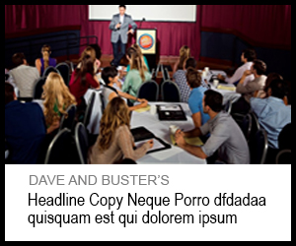
See next page for sample mock up

Mock up Sample:
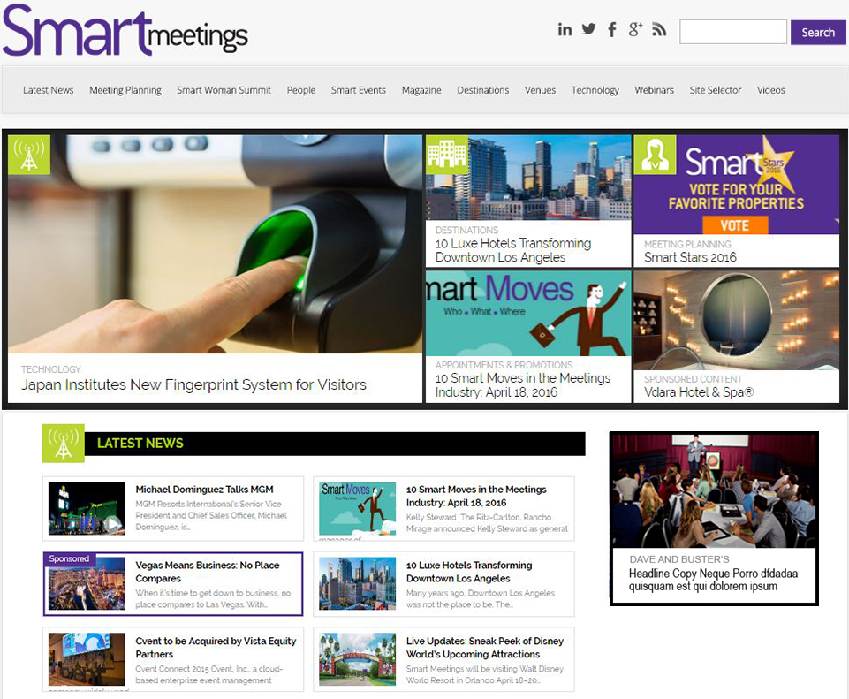
 NOTE:
The Native Content Banner is essentially a ROS Banner. Make sure that there is an actionable phrase in the copy. Like the example copy from Visit Seattle: Find out Why Meetings in Seattle Break Attendance Records.
Other Sample is: Take Your Meetings to Seattle
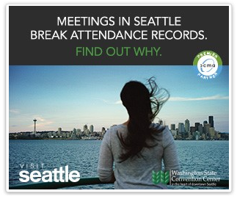

Continue to next page

2) ENEWSLETTER CONTENT MENTION
Provide up to FOUR (4) of the following assets:
a) Headline: 40 Characters with Spaces
b) Copy: 125 characters with spaces (…More must be included and is included in the count)
c) Photo: native resolution and size; we will resize photo to approx. 75 by 75 px
d) Click url
Sample:
Sample text to provide:
IMEX Frankfurt Highlights Sharing Economy
On the heels of Global Meetings Industry Day, IMEX Frankfurt holds celebrations with a politicians’ forum and focus on the sharing economy...More

